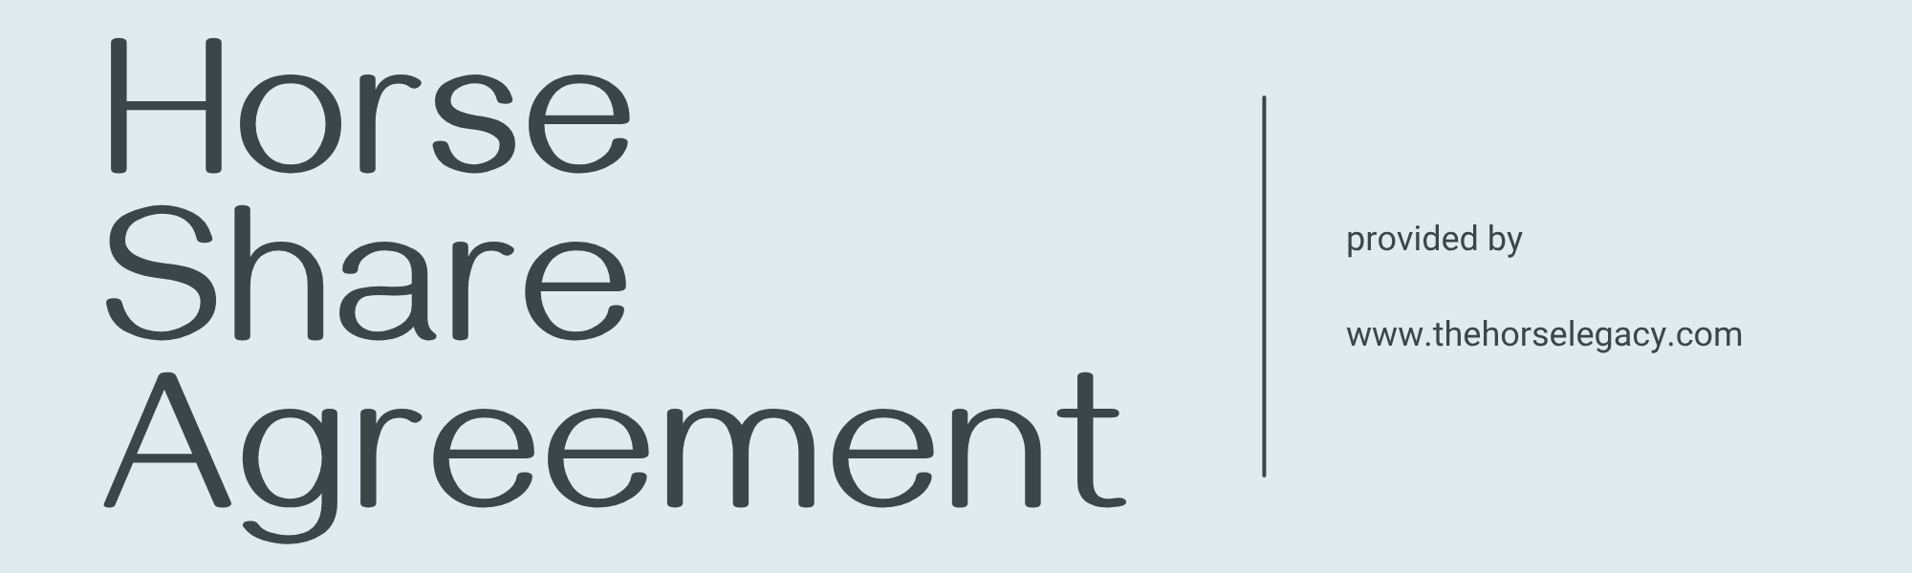
§ 1 – Parties
This agreement is made between
Horse Owner ( the “Owner”):
Name: ________________________________________________________________________________________
Address:______________________________________________________________________________________
Phone/Email:__________________________________________________________________________________
and
Rider ( the “Sharer”):
Name: ________________________________________________________________________________________
Address:______________________________________________________________________________________
Phone/Email:__________________________________________________________________________________
Together referred to as “the Parties.”

§ 2 – Purpose and Non-Transfer of Ownership
The Owner grants the Sharer permission to ride, handle, and care for the horse under the terms of this agreement.
No ownership, sale right, or permanent possession is transferred or implied.

§ 3 – Horse Identification
Name of horse:_________________________________________________________________________________
Breed/Sex/Year of birth:________________________________________________________________________
Passport/ID (if applicable):______________________________________________________________________
Boarding stable and address: ____________________________________________________________________
The riding participation includes riding, grooming, and exercising the horse on the days agreed upon.
Page 1

§ 4 – Riding Days and Use
The Sharer may use the horse on the following days and times:
______________________________________________________________________________________________
Riding, training, or transporting the horse outside the yard (e.g., hacking/trail riding, shows, clinics) requires prior Owner consent unless otherwise agreed below.
Permitted off-yard activities (tick if allowed):
☐ Hacking / Trail riding ☐ Lessons with approved trainer ☐ Shows / Competitions ☐ Transport by approved person / company
The Sharer/Lessee must prioritise the horse’s welfare and fitness at all times.

§ 5 – Financial Contribution
Monthly contribution (amount):__________________________________________________________________
Currency (€, $, £, etc.):___________________________________________________________________________
Due date each month:_________________________________________________________________________
Payment method (bank transfer / cash / other): _____________________________________________________
Optional duties provided in addition to or instead of payment:
☐ Mucking out ☐ Feeding ☐ Grooming ☐ Lunging ☐ Turnout ☐ Other: _______________________________

§ 6 – Care, Welfare, and Yard Rules
- The Sharer shall treat the horse humanely and responsibly, in accordance with recognised welfare standards.
- The Sharer must follow yard rules, safety policies, and Owner instructions.
- Any injury, illness, or behavioural change must be reported immediately to the Owner.
- Only safe, well-fitted, and Owner-approved equipment may be used.
- A certified riding helmet must be worn at all times while mounted.
- The Sharer shall not permit any third party to ride or handle the horse without the Owner’s prior consent.

Page 2

§ 7 – Veterinary, Farrier, and Routine Care
Default rule (select or amend as appropriate):
- ☐ Owner covers all veterinary, farrier, dentistry, vaccination, and routine care.
- ☐ Shared responsibility (define: e.g., 50/50 for routine, Owner pays emergencies): __________________________________________________________________________________________
- ☐ Other arrangement: _________________________________________________________________________________________
In emergencies, if the Owner cannot be reached, the Sharer/Lessee may authorise necessary veterinary treatment in good faith to protect the horse’s welfare.
§ 8 – Fitness and Competence
The Sharer confirms they are fit, competent, and experienced enough to ride and handle the horse safely for the intended activities.

§ 9 – Insurance and Risk Allocation
- The Owner confirms the horse is covered by suitable public or animal-owner liability insurance, where such insurance is required or customary.
Insurer / Policy No. (if applicable):____________________________________________________________
- The Sharer acknowledges that equestrian activities carry inherent risks. They ride and handle the horse at their own risk.
- The Sharer is advised to maintain personal liability and accident insurance covering equestrian activities.
- The Sharer is responsible for any damage caused by gross negligence or intentional acts.
- Nothing in this agreement limits liability where it cannot legally be excluded under local law (for example, death or injury caused by negligence where liability cannot be waived).

Page 3

§ 10 – Tack, Equipment, and Transport
- All Owner-provided tack remains Owner property.
- Any items purchased by the Sharer/Lessee remain theirs unless otherwise agreed in writing.
- Transport of the horse must only occur by the Owner or an Owner-approved competent transporter.
- Changes to saddlery, bitting, or feeding must be agreed in advance.

§ 11 – Lessons, Training, and Competitions
- Lessons may be taken only with: _____________________________________ (approved trainer / yard owner).
- Competition participation (if allowed):________________________________________________________
- Entry and show fees are paid by: ☐ Owner ☐ Sharer/Lessee ☐ Shared (specify): _____________________

§ 12 – Term and Termination
- Start date: ________________________________________________________________________________
- This agreement remains in effect until terminated.
- Either party may terminate with 30 days’ written notice (or as adapted locally).
- The Owner may terminate immediately for: unsafe or improper handling, non-payment, breach of agreement, or welfare concerns.
- Upon termination, all keys, equipment, and documents must be returned, and any outstanding fees paid.

§ 13 – Temporary Suspension (Illness or Injury)
If the horse becomes unfit for work, riding shall stop until veterinary clearance is given.
During suspension, contributions shall:
☐ Continue ☐ Reduce to ________ ☐ Pause ☐ Other: _______________________________________________

Page 4

§ 14 – Access and Data
- Yard access hours / conditions: ______________________________________________________________
- Keys / codes provided: ________________________ (to be returned at end of term).
- The Parties consent to sharing relevant contact data (vet, farrier, yard) for horse management only.

§ 15 – Governing Law and Jurisdiction (for Global Usage)
This agreement is governed by the laws of the country or state where the horse is kept.
The Parties shall first attempt to resolve disputes amicably.
If no resolution is reached, the competent court in that jurisdiction shall have authority.

§ 16 – Amendments and Entire Agreement
Changes must be in writing and signed by both Parties.
This document represents the entire agreement between the Parties and supersedes any prior verbal or written understandings.

§ 17 – Signatures
Place, Date: __________________________________________________________________________________
Signature of Owner: ___________________________________________________________________________
Signature of Sharer: ____________________________________________________________________________
If the Sharer is under 18, a parent or legal guardian must also sign:
Name / Signature: _____________________________________________________________________________

© TheHorseLegacy.com – Horse Share Agreement Template for Global Usage.
Adapt to your jurisdiction and verify compliance with local equine laws.

